Je m’appelle ____________________________ la date ______________________________

10-3: Apologizing, Accepting an apology, Reproaching someone

Apologizing

__________________________________________________ It’s my fault.
__________________________________________________ Forgive me.
__________________________________________________ Sorry. (adj – m/f?)
__________________________________________________ No hard feelings? *
__________________________________________________ I should have (called you).
__________________________________________________ I could have…(waited 10 more minutes).
__________________________________________________ I didn’t do it on purpose.

To accept apology  ______________________________________  It doesn’t matter.  ______________________________________  No big deal./ Don’t worry about it.  ______________________________________  No harm done.  ______________________________________  Don’t worry about it.  ______________________________________  No hard feelings. | 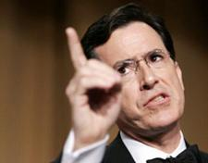  To reproach someone  ______________________________________  You could have…(listened to me).  ______________________________________  You should have…(called them).  ______________________________________  It’s all your fault.  ______________________________________  You did it on purpose.

