Nom: ___________________________ Team Cheer Mini Poster _____/15
Remind Mme to show sample
Les devoirs:
Vous allez créer un mini-poster pour encourager votre équipe/personne de sport/sport préféré.
-Include a minimum of FIVE COLOR images that represent (or are related to) your chosen
team/sports figure
-Include a minimum of FOUR cheering statements that you learned today in class.
Note: Madame likes these posters to be “pretty”, so create something that is worthy of being hung up in your own room to get full credit for “Creative & Aesthetically pleasing”. If your printer is not working, then you need to find one that is. Don’t hand in a lousy-looking mini-poster and say, “Oh, Madame! My printer was running out of ink!” Too bad for you and your grade. Plan ahead to address problems like this that arise.

RUBRIC
Correctly Used Minimum of 4 ‘cheering’ statements
(Correct: usage, conjugation, spelling, punctuation, capitalization)
8 7 6 5 4 3 2 1 0
Creative & Aesthetically pleasing mini-poster in COLOR
[Not in color? Grade = 50% as discussed in class.]

5 4 3 2 1

Handed in ON TIME
2 1 0 _____/15

- When possible, translate the team name in to French. The word “patriot” is translatable. So is “Blue devils”. When in doubt: ASK!
- Oui! You can choose a CRHS student who plays for a CRHS team.
- Hand in this rubric with your HW, or -3 points.

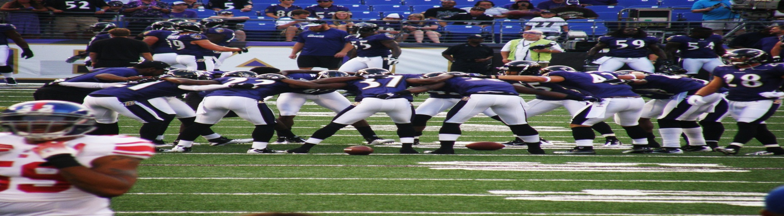
Mes Potes

