Je m’appelle ___________________________ # ______ la date ___________________________________
le français III, block _____ Révision: Générale et ch. 4 (la Martinique)

Avant qu’on puisse apprendre de nouvelles leçons, il faut réviser pour être sûr que vous comprenez la grammaire de base (y compris la conjugaison). Si c’est trop facile pour vous…pas de problème. Il est important que tout le monde comprenne cette grammaire au IIIème niveau!

1. What are the SUBJECT PRONOUNS [les PRONOMS] and what do they mean?
Singular | Plural
1
4

2
5

3
6

Si le sujet est nom + moi (ex: Jean et moi…) on utilise quelle boîte? ____________
la boîte =
box
Si le sujet est nom + toi (ex: Paul et toi…) on utilise quelle boîte? _____________
Si le sujet est nom + nom (ex: Claire et Paul) on utilise quelle boîte? __________

2. What are the 2 things you always need to know about a noun? __________________________________
3. WHY do we need to know these things? ____________________________________________________
________________________________________________________________________________________-
Zen Moment: If this is the case, why, oh why, do so many of you insist on NOT memorizing this? 

4. What is a DEFINITE ARTICLE? ____ _________________________________________
ex: Give me back _____ pen I lent you!

Quels sont LES ARTICLES DÉFINIS en français?

 | singular [singulier] | plural [pluriel]
masculine (m)
feminine (f)

When do we use them (in general) in French? ______________________________________________

5. What is an INDEFINITE ARTICLE? ___ or ___ __________ ________________________-
ex: I need ___ red pen. I need ___ orange marker.
Quels sont LES ARTICLES INDÉFINIS en français ?
 | singular | plural
masculine | un | DES  means “some”
feminine | une | DES  means “some”

Note: After a negative, these 3 words usually turn into: _______
Ex: J’ai un stylo.  Je n’ai pas ____ stylo.
6. POSSESSION
A. What is a POSSESSIVE ADJECTIVE? _________________________ ex: ___________________

Quels sont LES ADJECTIFS POSSESSIFS?

[owner] | (m) | (f) | (pl) | meaning?
(je)
(tu)
(il/elle/on)
(nous)
(vous)
(ils/elles)

In ENGLISH, what matters when we use possessive words? ____________________________
ex: _____________house ____________ house

In FRENCH, what matters when we use the possessive words? _______________________________
ex: HIS house: ___________maison HER house __________maison
THEIR pens: _____________stylos THEIR pen ____________stylo

MUSICAL MNEUMONIC: What song is going to help me remember these? ___________________

B. What is the other method is used to show possession? _____________

_______________ ___________________ ___________________

ex: Marie’s dog ➔ ___________________________________________________

Jacque’s birthday ➔ ___________________________________________________

Translate: my mom’s car ___________________________________________________

his sister’s book ________________________________________________
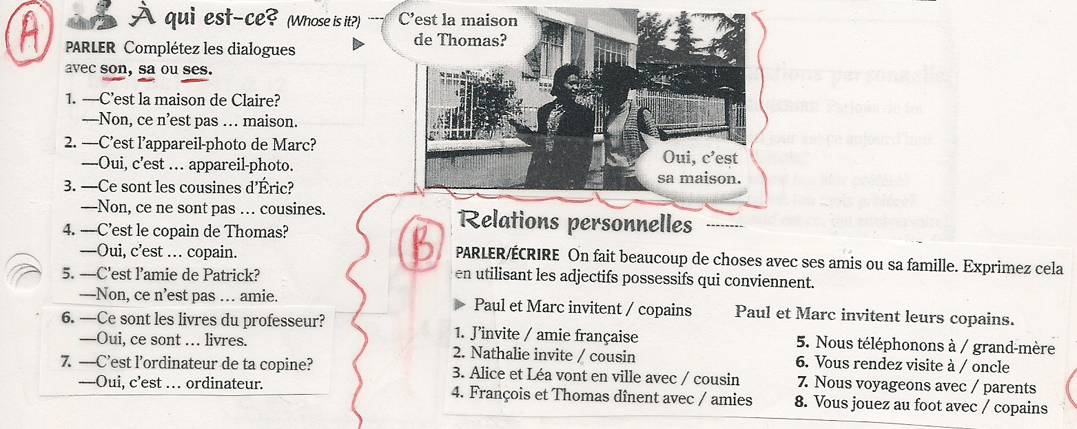

7. LES NOMBRES
one ___________ fifty ___________________ ninety _________________
ten ___________ sixty ___________________ ninety-six _______________
twenty ___________________ seventy ___________________ one hundred ___________
thirty ___________________ seventy-five ___________________ one thousand ___________
forty ___________________ eighty ___________________ one million ______________

5.899 _______________________________________________________________________________
2009 _______________________________________________________________________________
→ Write 2 big numbers down. Say them to your neighbor. S/He writes them down.
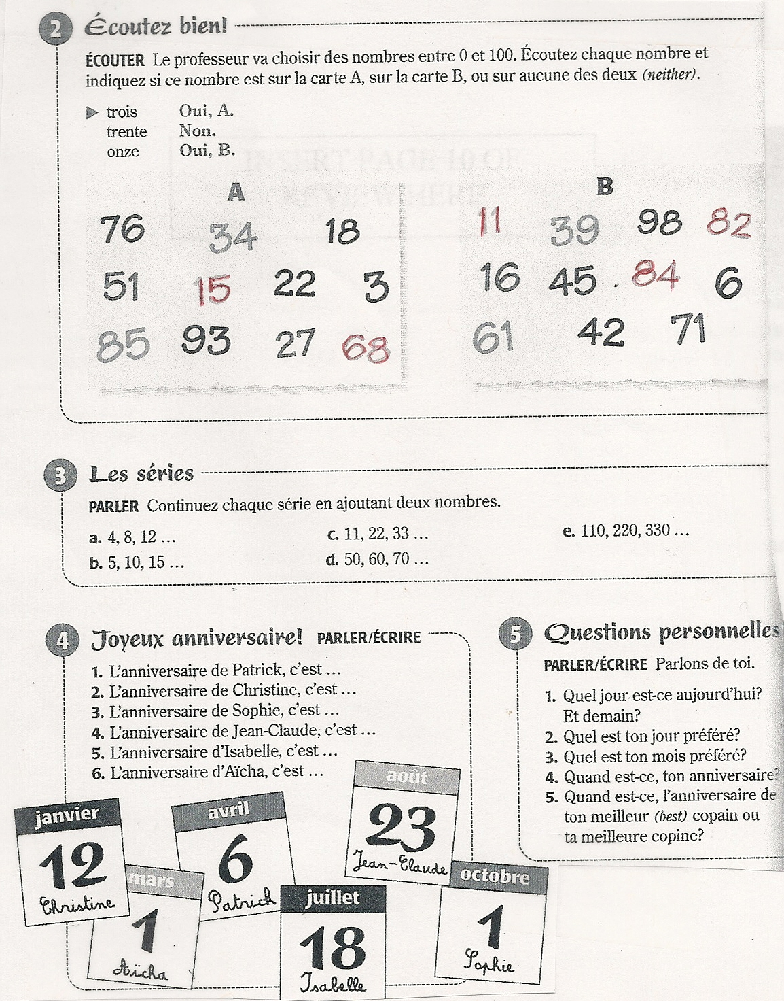
8. CONTRACTIONS
How do these words contract in English: a) I am  ____________ b) They are  ____________

DE and À both contract with LE and LES, [not with la or l’]:
 | le | les
de
à

9. NEGATION What 2 words to we use to negate? ______ _________
Where do they (most often) belong in a negative sentence?
____________________________________________________________________________
ex: Édouard parle beaucoup. _____________________________________________
What happens to ne before a vowel? _________________________________________
ex: Nous adorons la glace. _____________________________________________

Additional negation words that follow the same rule (surround conjugated verb) :
NEVER = _____ ___________ ONLY = _____ ___________
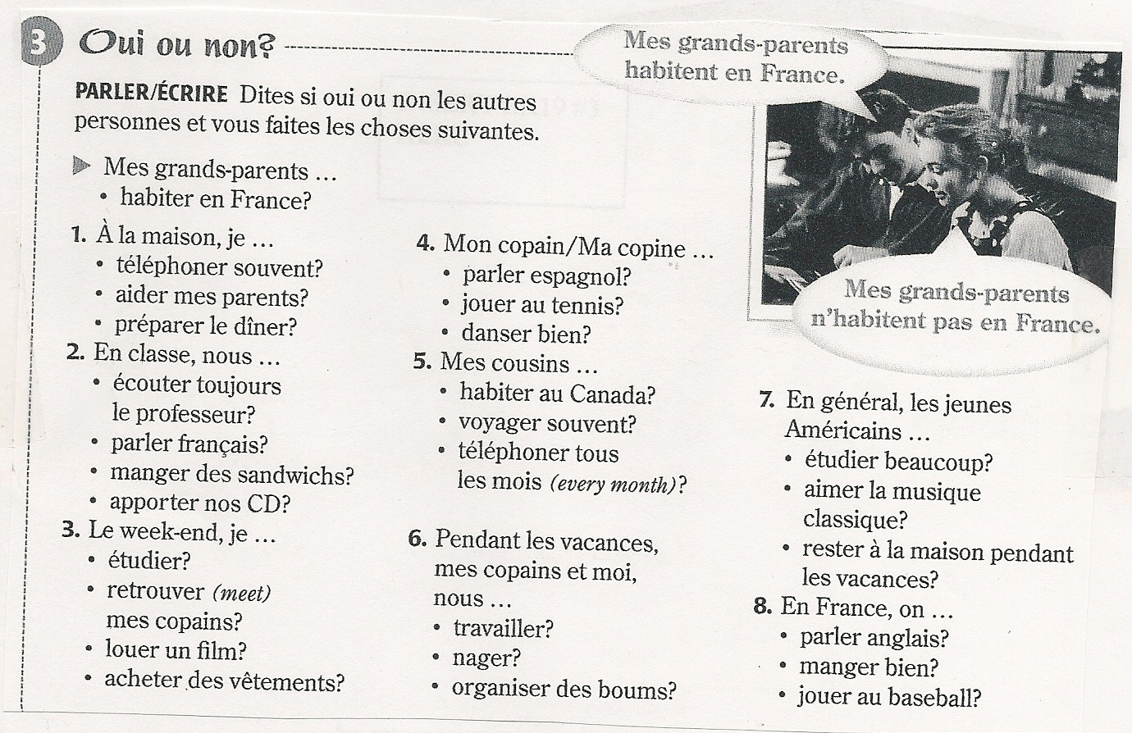

10. -ER verb conjugation -ER verb endings
Je/J’ | Nous
Tu | Vous
Il/elle/on | Ils/Elles

{Sing which song? __________________}

Conjugate this verb : étudier : _____________
Je/J’ | Nous
Tu | Vous
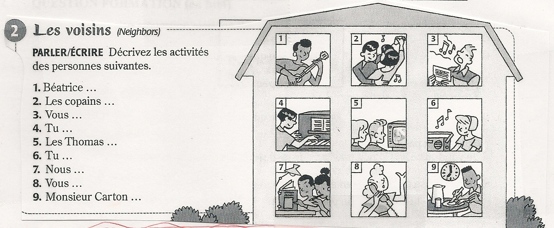  Il/elle/on | Ils/Elles

11. -RE verb conjugation -RE verb endings
Je/J’ | Nous
Tu | Vous
Il/elle/on | Ils/Elles

Conjugate this verb : vendre : _____________
Je/J’ | Nous
Tu | Vous
Il/elle/on | Ils/Elles
11. -IR verb conjugation -IR verb endings
Je/J’ | Nous
Tu | Vous
Il/elle/on | Ils/Elles

Conjugate this verb : finir : _____________
Je/J’ | Nous
Tu | Vous
Il/elle/on | Ils/Elles

12. QUESTION FORMATION (en bref)
- Intonation: slap a question mark on the end of a statement and use your voice to ask question.
Tu aimes le français?
- Inversion: Flip the subject and the verb and add a question mark.
Aimes-tu le français?
- Question words:
Est-ce que = ____________________________________ : gets a yes/no answer
_______________ tu aimes le français?
Qu’est-ce que = ___________________________________ : gets an information answer
________________ tu aimes? [Le français!]

- More question words :
Who = ______________
These are frequently followed by est-ce que when asking a question in a more “formal” way.

Ex: Why are you eating snails?

__________________________________________

Translate: At what time do you finish your homework?

__________________________________________

Why = ______________
Where = ______________
When = ______________
How = ______________
At what time? ___________________

